Capstone Project Summary - Section A

Program: Java Interface – Slab Inventory Trailer

Business Problem Summary:

I was asked by Ashley River Lumber to develop an inventory system that allows them to record information about cut slabs of wood in their inventory as well as slabs of wood that were sold. Up until this point, their business had not had an inventory system because they had not really had a need. They had started recording inventory in Excel spreadsheets but they were not technically capable of creating a spreadsheet that had the features they needed. I first started with their Excel spreadsheet and captured the functionality they wanted for this information. I told them that Excel would work for a small inventory but for the purpose of tracking thousands of wooden slabs they would need a database. I spent the end of last year and part of January developing a Microsoft Access database that had the functionality that they needed. When I was finished, I realized that while the database had the requirements they needed, it was somewhat buggy and allowed users too much freedom to destroy or corrupt the database. I also was not happy with the limited functionality I was able to give them. For my capstone, I decided to develop a Java interface for the database to see if I could improve the design as well as streamline it some. Another advantage is the interface allows multiple people to work on the database simultaneously.

Software Development Lifecycle: Waterfall/Iterative

I had to go with waterfall for the development of the Microsoft Access database because the client was not available to test the product as I went. They were able to give me requirements up front that the inventory system would need but they have no time to test the product yet. As I developed it, I spoke with the client to ask particular preference to design decisions that came up as I went. Up until now though, the client has not been able to test the original Microsoft Access database. They have just reached a point where they will start tracking freshly milled slabs that will then sit for 1 to 5 years drying before being sold. I plan to make adjustments as needed once I get client feedback. This portion of the development will be more iterative. Later they will want to add more features and options to the database that will also be an iterative process.

Deliverables:

* + Microsoft Access Database: SlabsDb v1.53.accdb
  + Java Interface: Slab Tracker

Implementation:

The Microsoft Access Database will be installed on a desktop computer in the main office of the lumber mill. The interface can be installed on laptops and the main computer to connect to the database through there already present network. They will then be able to add slabs from any part of the lumber yard as long as they have network access and the interface installed. Also, this will allow the receptionist at the main office to see what slabs are available and inform customers that call in what is present in the lumber yard without having to send someone to check each time there is an inquiry.

Verification:

* Before installation: I have created an extra class in the utilities package that allows me to create dummy data in any number that I need. I plan on stress testing performance and functionality with 20,000 inventory items. This is twice the amount that the database needs to hold. I have performed unit test to ensure reports and functions behave as expected. I have also been doing this as I go as well as regression tested the whole system once it was complete.
* Onsite: When the client is ready, I will go onsite to help with installation of the system. I will then verify that the Java interface works from the laptops as expected.

Costs:

Customer:

* Database Administrator/Software Developer - $30/hr. I only charged this price for development of the Microsoft Access Database. The Java interface I created free of charge because they still had not tested the original database and it met requirements for my Capstone. I spent 40.5 hours developing the database and charged a total of $1,215.
* Microsoft Access - $129 is the current cost. This is the current price; I am not sure what they paid as a business.
* UCANACCESS API - $0 - freeware Java based API used to connect to Microsoft Access Database

Personal:

* Netbeans IDE - $0 - used to develop interface
* JavaToExe - $15 - converts Jar file to .exe so it can be run on any windows machine
* Microsoft 365 Office - $6.99/month - used to create Access Database

Software Development Life Cycle:

Below I have summarized the Timeline into Milestones. I would like to summarize how this corresponds to the software development lifecycle. I would also like to note that I finished the finished the database and then developed the Java Interface. In this fashion, I built the two pieces iteratively. I will also say that the design was split between the meeting with the client and during the development milestones. I understood what the client wanted and had designed the interfaces but once I made the GUI, I changed design to make it more user friendly and to keep database integrity in ways I had not foreseen were necessary.

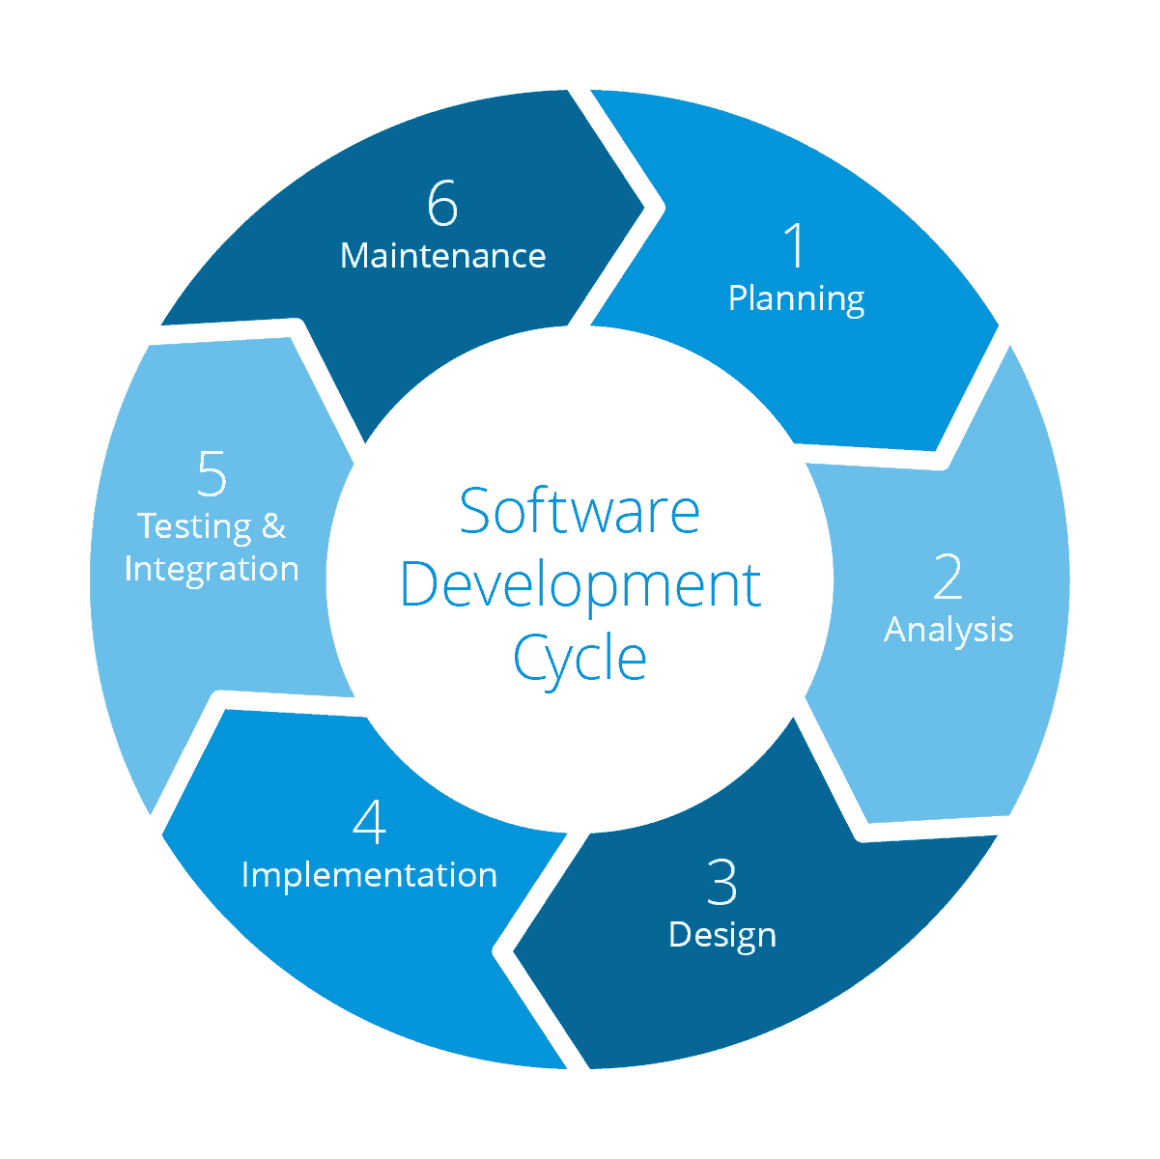

* + 1 Planning – Corresponding Milestone - Meet with Client and Planning
  + 2 Analysis – Corresponding Milestone - Meet with Client and Planning
  + 3 Design – Corresponding Milestone - Microsoft Access Database Development/ Coding Java Interface Development
  + 4 Implementation – Corresponding Milestone - Microsoft Access Database Development/ Coding Java Interface Development
  + 5 Testing and Integration – Corresponding Milestone – Test Database and Interface/Installation and Training
  + 6 Maintenance – Corresponding iterative cycle - On-going Maintenance Schedule

TimeLine:

* **Milestone**: Meet with Client and Planning: 11/25/2018 - 11/30/2018. Resource: Ben Lucas for ALL STEPS
  + Meet with Client to gather requirements - 11/25/2018
  + Planned best way to move forward - 11/26/2018 - 11/30/2018 – Dependency – Meet with Client to gather requirements
    1. Tested client’s excel spreadsheet and found it lacking for client’s needs
    2. Suggested Microsoft Access Database
    3. Client Agreed
* **Milestone Complete**: Meet with Client and Planning
* **Milestone**: Microsoft Access Database Development: 12/1/2018-12/15/2018. Resource: Ben Lucas for ALL STEPS
  + Create Tables - 12/1/2019-12/3/2018 - Dependency – Planning
    1. AddOnPrices
    2. SlabEntry
    3. SoldSlabs
  + Create Queries – 12/4/2018-12/9/2018 – Dependency – Create Tables
    1. All In Stock Slabs (LG&SM)
    2. Dry In Stock Slabs (LG&SM)
    3. All Sold Slabs (LG&SM)
  + Create Reports 12/10/2018 – 12/15/2018 – Dependency – Create Queries
    1. All InStock Slabs
    2. Dry InStock Slabs
    3. All Sold Slabs
* **Milestone Complete**: Microsoft Access Database Development
* **Milestone**: Microsoft Access Database Development - 12/16/2018 - Resource: Ben Lucas for ALL STEPS
  + Performed tests on Microsoft Access Database to ensure expected functionality - Dependency – Complete Database
* **Milestone Complete**: Microsoft Access Database Development
* **Milestone**: Coding Java Interface Development: 8/21/2019-9/9/2019 Resource: Ben Lucas for ALL STEPS
  + Create Object Classes - 8/21/2019 – Dependency – Complete Database Testing
    1. Wood (Abstract Class)
    2. InStockSlab (extends Wood)
    3. SoldSlab (extends Wood)
    4. Species
  + Establish Database Connection 8/22/2019 – Dependency – Complete Database
    1. DBConnector Class
    2. Statement Maker Class
  + Create Database Interaction Methods – 8/23/2019 - 8/25/2019 – Dependency – Establish Database Connection
    1. DAO Class
  + Create Sample Data Classes - 8/26/2019 – Dependencies – Complete Object Classes/Complete Database Connection/Create Database Interaction Methods
    1. SampleData Class
  + Create GUIs - 8/27/2019 - 9/2/2019 – Dependencies – Create Object Classes/Establish Database Connection/Create Database Interaction methods
    1. Gather Background Pictures
    2. Create GUIStyleSheet.css
    3. DatabaseLaunchWindow Class
    4. SlabTracker Class
       1. InStock Tab
       2. Sold Tab
       3. Species Tab
       4. Reports Tab
       5. Utilities Tab
  + Create GUI functionality - 9/3/2019 - 9/9/2019 – Dependencies – Create GUIs
    1. Create Filters
    2. Create Button Functions for each GUI interface
    3. Create Report Generator functions
    4. Create Password table for holding password data
    5. Create Import/Export/Change Database Functions
* **Milestone Complete**: Coding Java Interface Development
* **Milestone**: Test Java Interface - 9/10/201 Resource: Ben Lucas for ALL STEPS
  + Performed tests on interface to ensure expected functionality - Dependency – Complete Java Interface
* **Milestone Complete**: Test Java Interface
* **Milestone**: Create Manual and Train Employees: 9/11/2019-9/20/2019 Resource: Ben Lucas for ALL STEPS
  + Create Manual - 9/9/2019 – 9/10/2019 – Dependency – Complete Java Interface Testing
  + Installation and Training for employees - 9/20/2019 - Dependency - Create Manual
    1. Onsite Installation
    2. Network communication testing
    3. Employee training for software use
* **Milestone Complete**: Create Manual and Train Employees
* **On-going Maintenance Schedule:**
* Begins: 9/21/2019 Resource: Ben Lucas for ALL STEPS
* **Two week iterative cycle:**
  + Get feedback from client - Day 1
  + Research and test software changes - Day 2 - 5
  + Propose software changes Day 6
  + Client approval - Day 7
  + implement software changes - Day 8 - 9
  + Get client feedback - Day 10